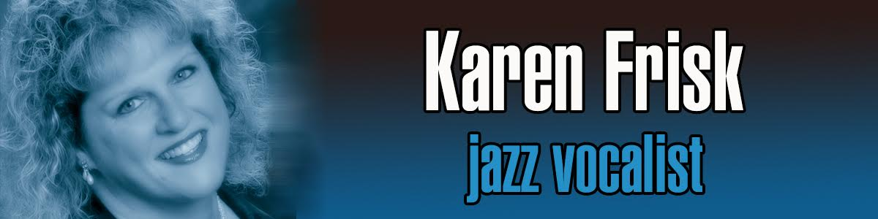
Karen Frisk www.karenfriskmusic.com

Karen Frisk is a jazz vocalist who has performed in several areas of the country with local and world-renowned jazz artists.
Originally from Cromwell Connecticut, Karen always claimed she was singing before she was speaking. She started singing with recordings at the age of four and by the time she was seven she entertained the neighborhood by holding small musical productions in her home. After participating in church choirs, local community musical theatre productions and studying classical piano and voice at Richard Donohue Studios, Karen was selected to tour Bavaria and perform with the Concordia Youth Choir sponsored through the Boston Conservatory.
In her late teens the “jazz bug” bit her… swing, latin jazz and R&B filled her soul and the rest is history. She studied jazz piano with Merrill Doucette at the Hartford Conservatory and then moved on to study jazz/pop vocals and performance with Roberta Peck-Vater, a well known music educator and Capitol Records recording artist.
Karen lived on Cape Cod for 10 years before moving back to Connecticut. She worked with local and Boston area musicians, participating in benefit concerts, jazz venues, and weddings. She has shared the stage with many premier jazz artists including world-renowned pianist: Dave McKenna; Artie Shaw Orchestra band leader: Dick Johnson; Tony Bennett’s guitarist: Gray Sargent; legendary drummer: Bernard “Pretty” Purdie; world renowned bassist: Brian Torff; pianists/arrangers: Donn Trenner, John DiMartino, Mike Renzi, and others.
Karen’s versatility offers a very diverse sound. Within her 5-octave range, her vocal styles cover breathy ballads to heart-wrenching blues, sexy Latin rhythms to up-tempo swing and more. Although she has been influenced by some of her favorite artists… Sarah Vaughan, Carmen McRae, Ella Fitzgerald, Shirley Horn, Maxine Sullivan, Rosemary Clooney… Karen has developed a sound all her own. She is considered one of the most respected premier jazz vocalists in Southern New England.
She’ll bend the notes, play with the timing and keep swingin’! What a percussive rhythm machine!

